TBC Assignment 3: Fundamentals of Valuation
(Due: Saturday 11:59 PM)
Note: Don't worry if you find some of these questions confusing and/or don't know the answers. They are intended to help you flesh out where there might be gaps in your understanding of accounting; they are not intended as a test. Simply try to work your way through them and collect any questions you have to ask your discussion leader when you meet on the weekend. As a reminder, when it comes to assignments, we care about effort/thoughtfulness, not correctness.
Required Readings:
- The Little Book of Valuation (Chapters 1 + 3)
- Dangers of the DCF
Optional Viewing:
- Building a google DCF here

Enterprise Value:
- What is the difference between market capitalization and enterprise value?
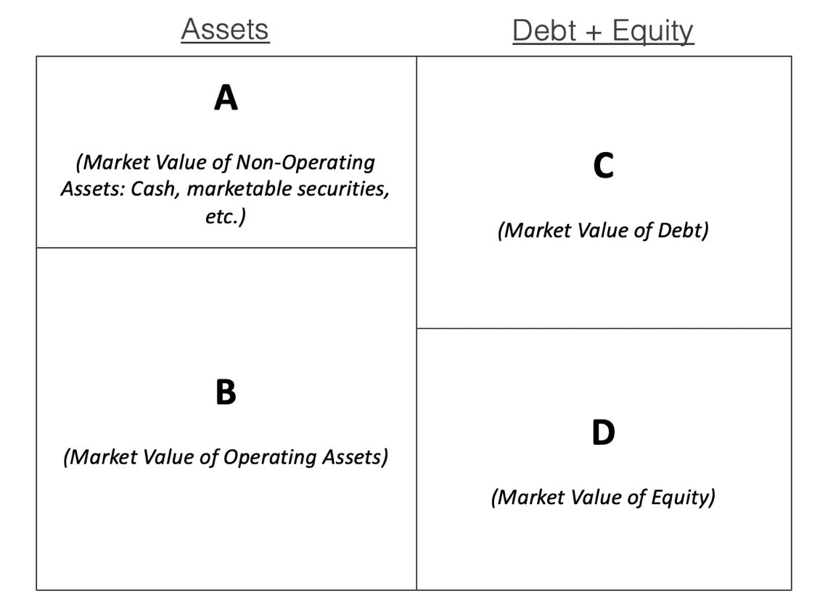
Market capitalization is the equity value of the company, not the enterprise value. The difference is that the enterprise value is the value of the entire firm, that is, whatever an acquire would have to pay to buy the business, whereas the market cap is only the value of the equity in the firm. This difference in values is accounted for by the fact that the enterprise value also includes the net debt of the company, that is the total debt – cash and investments, which is not reflected in the market cap.
- Consider the following diagram, which presents a simplified portrayal of a company. (Recall from lecture 1 that although we generally use balance sheet diagrams like this one in the context of accounting, we can just as easily create ‘balance sheets’ which are based on market values instead of book values. The basic balance sheet equation (A = L+ SE) must still hold for market values).
Based on the diagram, answer the following questions:
  - When we do a DCF valuation, which box are we estimating the value of? (That is, which box represents the present value of a company’s discounted cash flows?)

B

  - Which box represents a company’s enterprise value?
B. Is equal to a)
  - Which box represents a company’s market capitalization?
D
  - Using the boxes, show how we can calculate a company’s market capitalization if we know its enterprise value. (E.g. you could write A = B + C – D)
Always A + B = C + D
D = B – C + A

Free Cash Flow:
- What is the formula for Free Cash Flow?
Unlevered FCF (FCFF) = EBIT * (1- Tax Rate) + Depreciation & Ammortization – Capital Expenditures – Change in net working capital
- Give an intuitive explanation for why we add back D&A and subtract capex to arrive at FCF (do not simply write “because D&A is a noncash expense”).
(Hint: In what way is it similar to subtracting increases in working capital assets?)
We subtract net working capital because a higher net working capital means more cash tied up in running the business operations. D&A, on the other hand, does not reflect any cash being tied up or expensed in the working of the business, however it has been recorded as an expense in the income statement and so reflected in the EBIT being used to calculated the FCFF. Since this would represent an inaccurate value for the cash being tied up in the business, the D&A is added back to accurately reflect the value for the same. Similarly, the capital expenditures reflect cash that is tied up in the business, that is business expenses, but are not accounted for in the value of the EBIT used for the FCFF, hence their contribution for cash being tied up into the business is subtracted to get an accurate value for the same.
- A company purchases $50 in inventory from a supplier. It pays the supplier $25 today and agrees to pay the remaining $25 six months from now. What effect does this have on the company’s free cash flow for the current month? Which term in the free cash flow equation would this transaction effect?

-$25 for the capital expenditures, + $25 in working capital liabilities, which is subtracted from the FCFF.
Thus free cash flow decreases by $50.
WRONG: $25 Accounts payable, Inventory $50, net working capital only deals with cash expenses.
$50 in net working capital, have given only 25 of that, hence it goes down only by 25.
WACC:
- You friend offers to pay you $200 five years from now. This future payment is worth $100 to you in present value terms. What is your discount rate?
DCF = FV/ (1+R)^n, Then PV*(1+r)^n = FV, r = (FV/ PV )^1/n – 1 = (200/ 100) ^ 1/5 -1 = 14.87%

Practice Modeling: (Note please complete all models on Excel). If you do not have it downloaded, please go through here.
- Fill out the spreadsheet titled “Assignment-3-DCF”.
- Please project Tesla’s 2026 US electric car revenue given the information in the spreadsheet titled “TSLA Revenue Build”.

Note: UChicago gives you a ton of free software that you should take advantage of. Personally, I have used ~100-150k of free software through the school. For TBC I would recommend Refintiv and Factset.

